- Architecture:

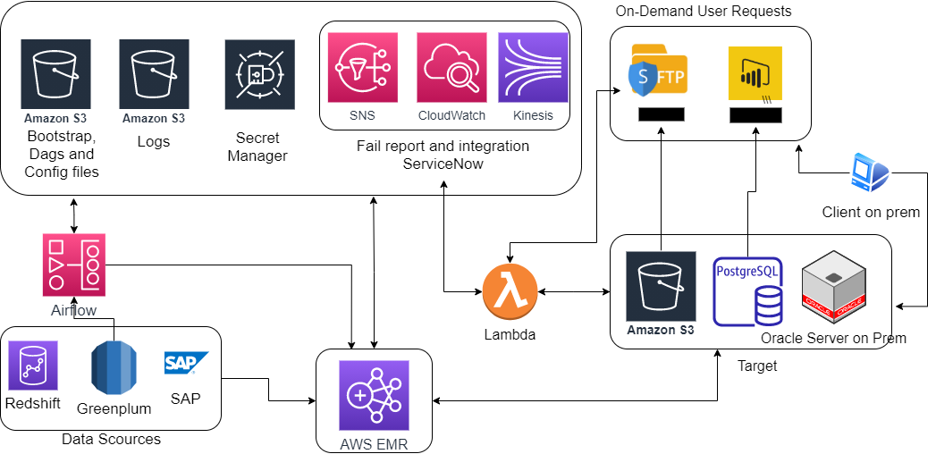

- No of users:

- Application ranking:

- Vendor: None

- ITSC training: NA

- OpSec documentation: NA

- CPIs in remedy: NA

- Access required to:

- FPL AWS Prod: FPLProd-PO164-ViewOnly-ADFS
  - ALR postgres
  - Lambdas
- FPL NonProd: DevOps
  - ALR postgres
  - Lambdas
- CSDataDEV
  - MWAA DAGs
  - Application code
- CSDataProd
  - MWAA DAGs
  - Application code

- S3 Buckets and FileZilla Connection for adhoc and LSE files
  - Adhoc S3 bucket. Can be accessed from FileZilla: 2epv-lo174-cs-data-input-s3
Host | sftp-int.nee.com
Port | 22
Username | edp-lr-lo174-dev
Authentication | aws-sftp-key.ppk
  - Archive S3 bucket, can be access from FileZilla
Host | sftp-int.nee.com
Port | 22
Username | edp-lr-archive-IA-lo174-prod
Authentication | aws-sftp-key.ppk
  - Configuration S3: 2fpv-lo174-configurations-logs-s3
  - Data input and output S3: 2fpv-lo174-alr-s3
- ALR Database connection
  - Host: aws-fpv-lo174-clrp-cluster-0a76fdf35965-rds.cluster-cgqep0gwcrlg.us-east-1.rds.amazonaws.com
Port: 5605
Database: clrp
Username: clr_ro_user
Password: See CyberArk Vault
    - https://pam-vault.access.nee.com/PasswordVault/v10/logon?returnUrl=%2F
- Updating application code in CSData Prod:
- Merge github from dev prior to committing and pushing changes
  - https://github.com/NextEraEnergy/lo174-csdat-load_research/tree/dev
- Commit and push changes to Dev in github
- Review contents of: css_data_alr_package
  - If any folders or files already in the package were changed, update those
- Find the changed files in S3 and update them. Folder structure generally follows the project structure:
  - 2mpv-lo174-configurations-logs-s3
  - Airflow DAGS = 2mpv-general-airflow-s3

- Daily run of LR
- Checks cycle day
- Runs Fetch data module: load_research_data_fetch dag
Runs Validations: load_research_validations dag
Runs lse file: load_research_lse dag

To run for another date, you can include below parameters. For today is that is not
required as today is default value.
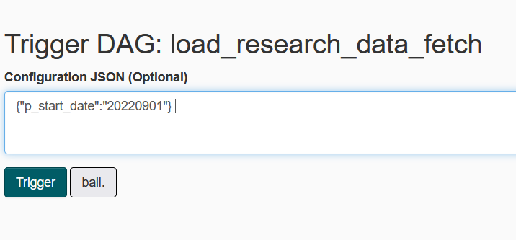

- The date entered for p_start_date {"p_start_date":"20230610"} when running the daily process manually is the date of the day that failed for automatic processing. If today failed and the process is run manually the same day, then p_start_date is today. If yesterday’s process failed, then p_start_date is yesterday’s date.

- Daily run of load_research_data_fetch_backdated:
  - Processes any new backdated studies, including validation and lse processes

- Daily run of load_research_reprocess:
  - Processes any reprocess requests, including validation and lse processes

- Monthly run of long-term archive: Runs the first of every month at midnight UTC
  - Archives data in ALR that is no longer needed, on month at a time

- Error notification:

To get SNS notifications, email id needs to be added to the below group.
- 2fpv-lo174-sns-topic for lambdas
  - https://servicenow.nexteraenergy.com/esp?id=sc_cat_item&sys_id=e995517adba3a010ccf483aa139619fc
    - Select cloud provisioning
- 2mpv-lo174-sns-topic for MWAA DAGs
  - Log into CSData Prod and add or remove recipients as needed
To get splunk notifications, id needs to be added to
  - FPL.com_LOAD_RESEARCH-SERVICE-NOW_Error
  - User also needs Splunk general access. Search for splunk access in Confluence for directions.
AWS Cloudwatch
- Splunk logs: 2FPV-LO174-FPL-LR-LG
- DAG logs: 2mpv-lo174-fpl-lr-logs
- Adhoc logs (Not integrated with splunk)

(Lambdas are in the document. same should be in Dev account. FPL nonprod.)
  - /aws/lambda/2fpv-lo174-Adhoc-LF
  - /aws/lambda/2fpv-lo174-Adhoc_env_ctl_files-LF
  - /aws/lambda/2fpv-lo174-MonthlyStratum-LF

- Negative, performance and load test scripts and results. Assumptions and profile: NA

- Storm application: NA

- Code repository in Github:

  - https://github.com/NextEraEnergy/lo174-csdat-load_research/tree/dev

- DR documentation for MC and BUI application: NA

- Execute and provide DR testing detailed checklists and results: NA

- Contact list:
- Application owner: Regulatory Team (Tara Dubose)
- Testers
- Developers: CS Data (Dania Triff)

- SOX application: NA

